Becoming aware of our attitudes towards languages and cultures

  - How do we feel when we’re exposed to another language, another culture?
  - How do we draw on our previous experiences to make sense of a new experience, encounter?

How can we make learners aware of their preconceived ideas?
How can we make learners aware of the benefit to be derived from comparing ideas and points of view?

Exemplar classroom resource 1:

In groups learners discuss about what we can guess / know from a name.
Write your name(s) !



Does your name have any meaning?
Do you know where your name comes from? Do you think it’s important, do you think it tells something about you?
Does your name show which country you come from?
Is your name easily translatable to English or other languages?
If so what would it be in English, in other languages?
Have you got a nickname? Who gave it to you? Does it say anything about you?
How do people address you? Do all people address you in the same way? Why (not)? Did anything change at some point? Why?
How are you likely to be addressed? How would you like to be addressed?
Do you think it’s the same in other traditions, have you already been surprised by the way people addressed you?
Do you keep traditions when naming a child in families?
Does the way the name is ‘constructed’ say anything about the society you live in?
- How does it influence a person when they carry the reference to their father in their name?
- Does it define them in any way? What does it tell you about the society
- Do you think it appropriate for women/men to take their spouses’ surnames?
- Do you find it common/insulting that women’s forms of surnames in some societies/cultures suggest the idea of being owned?

If they wish so and if the resource is available, they can look at different websites giving information about the meaning of names.

Source : LEA – Plurilingual and pluricultural awareness in language teacher education – A training kit – ECML – 2007 - Author – Petr Najvar - https://www.ecml.at/en/Resources/ECMLresources/ID/56

Possible objectives for learners:
Get to know each other.
Create a group dynamic.
Have pleasure working with languages.
Explore identity.
Explore and play with languages.
Become aware of similarities and differences.
Become aware of linguistic phenomena.
Become aware of cultural habits.

Exemplar classroom resource 2:

A B C D E
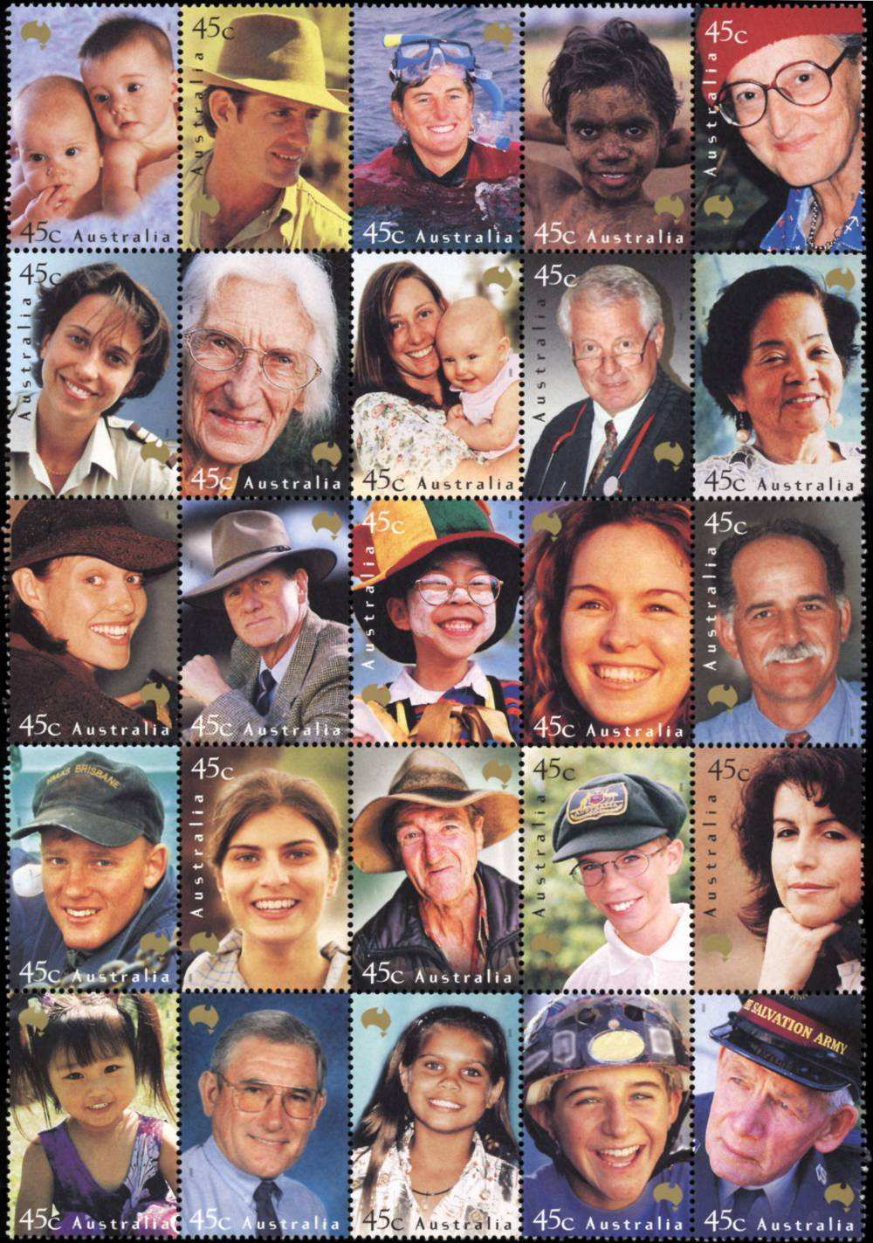

1

2

3

4

5

In pairs, one person thinks of one of the people above and describes what he thinks his life could be, whilst the other one tries to guess who it could be.

Where are they from? What is their educational background? What is their job? Which language(s) do they speak? What are their hobbies? What about their past lives? Other details?

They discuss why they have made up this “biography” and what made them think it was this or that person.

Source : LEA - https://www.ecml.at/en/Resources/ECMLresources/ID/56

Possible objectives for learners:
Reflect on the differences of perceptions.
Reflect on possible prejudice.
Compare preconceived ideas.
_______________________________________________________________________

Exemplar classroom resource 3

In groups, the learners are encouraged to think of different consciously used gestures that are used in their own country, region, family; and / or the ones they have come across while travelling or when communicating with family overseas (in case of migration background); or in any other encounter.
They are encouraged to discuss how they consider these gestures and whether they can be ambiguous or not.

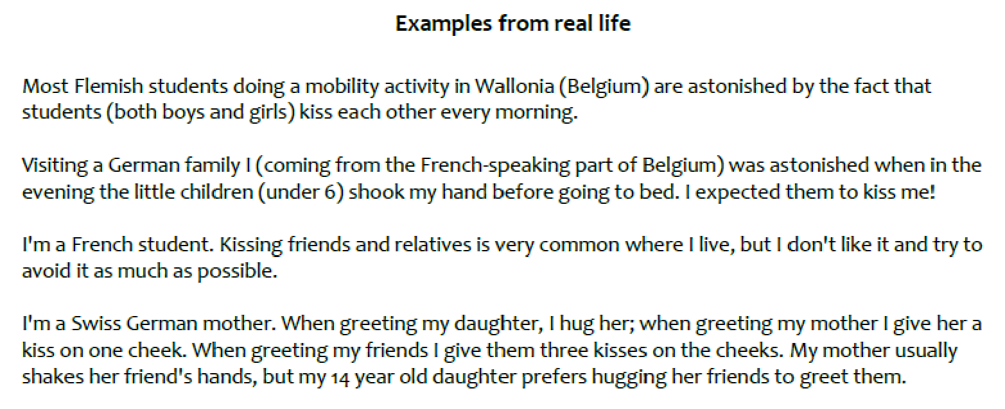

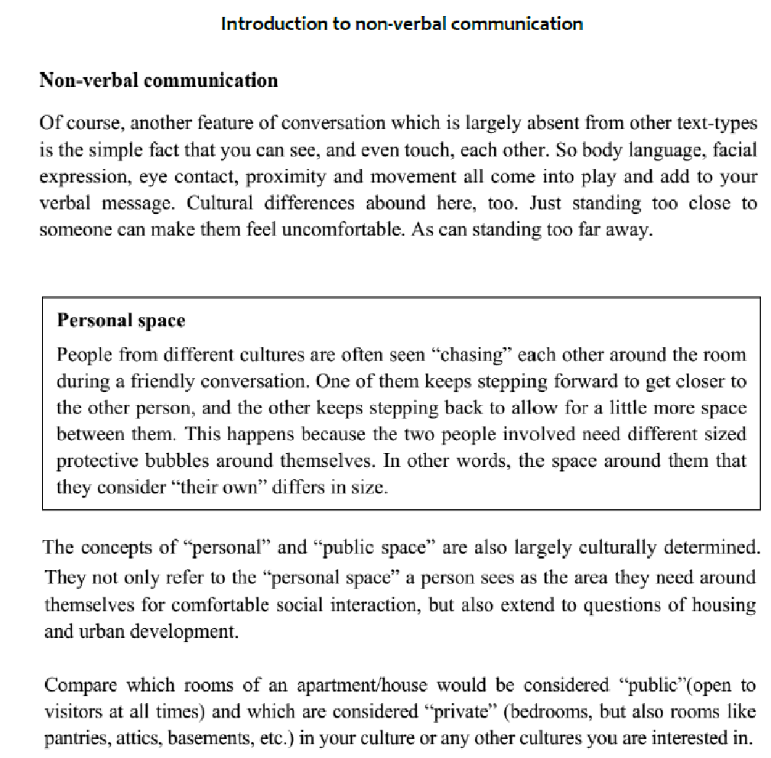

Source : PluriMobil – Lesson plans for upper secondary – Lesson plan 11
https://plurimobil.ecml.at/Portals/37/LP_UPPER%20SECONDARY%20GENERAL%20FINAL.pdf

Possible objectives for learners:
- Become aware of their non-verbal communication in their own culture and other cultures.
- Discuss non-verbal communication.
- Know that there are differences in non-verbal ways of expressing feelings.
- Acknowledge that there are different non-verbal ways of expressing feelings.

Reflective questions:
How do these resources address the initial questions?
How do learners benefit from them?
What other objectives could you achieve with these activities?
How would you use these resources and adapt them for your own context?

Food for thought:
Autobiography of Intercultural encounters – Context, concepts and theories
https://rm.coe.int/context-concepts-and-theories-autobiography-of-intercultural-encounter/168089eb76
Autobiography of Intercultural encounters – Concepts for discussion
https://rm.coe.int/concepts-for-discussion-autobiography-of-intercultural-encounters/168089ea7f
Autobiography of intercultural encounters – On-line self-study course for educators
https://www.coe.int/en/web/autobiography-intercultural-encounters/online-self-study-course-for-educators

Other resources:
LEA - Language educator awareness - https://www.ecml.at/en/Resources/ECMLresources/ID/56

